**AFRL Research Collaboration Program**

**Contract FA8650-13-C-5800**

**Effect of Constituents and Microstructure on Energy Dissipation Mechanisms During Damage Growth**

**University: Texas A&M University**

**REPORT COVERS PERIOD: XXXXXX THRU 6-30-18**

Currently covers 3/1/17-3/31/18

1. **PROJECT TEAM MEMBERS**
2. **LEAD UNIVERSITY POC:** John Whitcomb, 979-845-4006, jdw@tamu.edu
3. **PROJECT TEAM MEMBERS:** John Whitcomb, Collin Blake
4. **AFRL TECHNICAL POC:** Craig Przybyla
5. **TECHNICAL DISCUSSION**
   1. **CURRENT WORK**

Development of the infrastructure to perform mesoscale analysis of 3D textile composites.

**Background**

Virtual Textile Morphology Suite (VTMS) is a composite textile generation software that was developed at the Air Force Research Lab (AFRL). Previous geometries created by VTMS that have been used for analysis were found to have interpenetrations between the surfaces that represent the bundles of fibers referred to as tows. These tow surfaces should not interpenetrate. Physically, the result should be a contact between the two surfaces that deforms each surface. The origin of these interpenetrations will be further discussed in detail. There have been previous attempts to fix these interpenetrations [1,2]. These fixes have been listed but not heavily documented. This groups own solution to date has been to shrink the tow cross-sections until there are no penetrations left. While this method works, it overly affects the material properties of the analysis by under-estimating the fiber volume fraction. This solution also does not effectively model the result of two tows lying across each other with no matrix pocket between the two tows. Because of these two draw-backs, we decided to develop our own method to solve these surface interpenetrations.

**Approach**

While at Texas A&M, VTMS was further explored so that he could further efforts in using this software for research. Also, another similar type of software, call DFMA, was explored. This software is developed by a research group from Kansas State University. Eric Zhou was a member of his group during his time at Kansas State. This exploration of DFMA lead to a deeper understanding of the input parameters that is used by VTMS as both software use a derivative of the digital chain method. From this new understanding, a process similar to that in Figure 1 can be conducted on a complex geometry like in Figure 2.

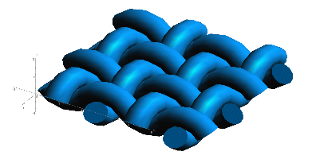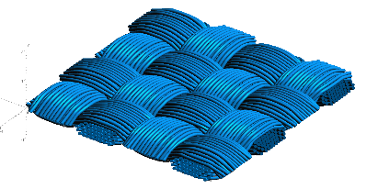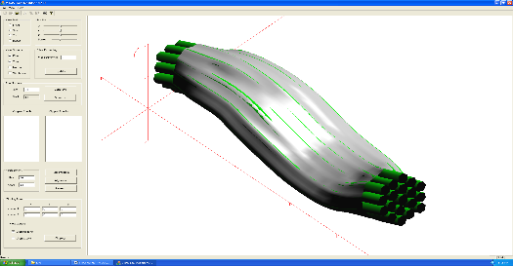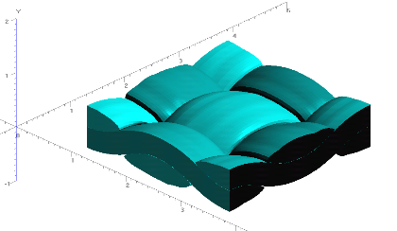

**Figure 1: Evolution of Weave Tow Geometry**

**a) Generic Approximation of Woven Pattern**

**b) Filament Representation of Pattern**

**c) Surface Approximation of Filament Bundles**

**d) Volume Model Derived from Surfaces**

Figure 1.d shows a volume representation of a collection of filament bundles derived from a surface representation shown in Figure 1.c. It is at this step that interpenetrations between the surfaces appears.

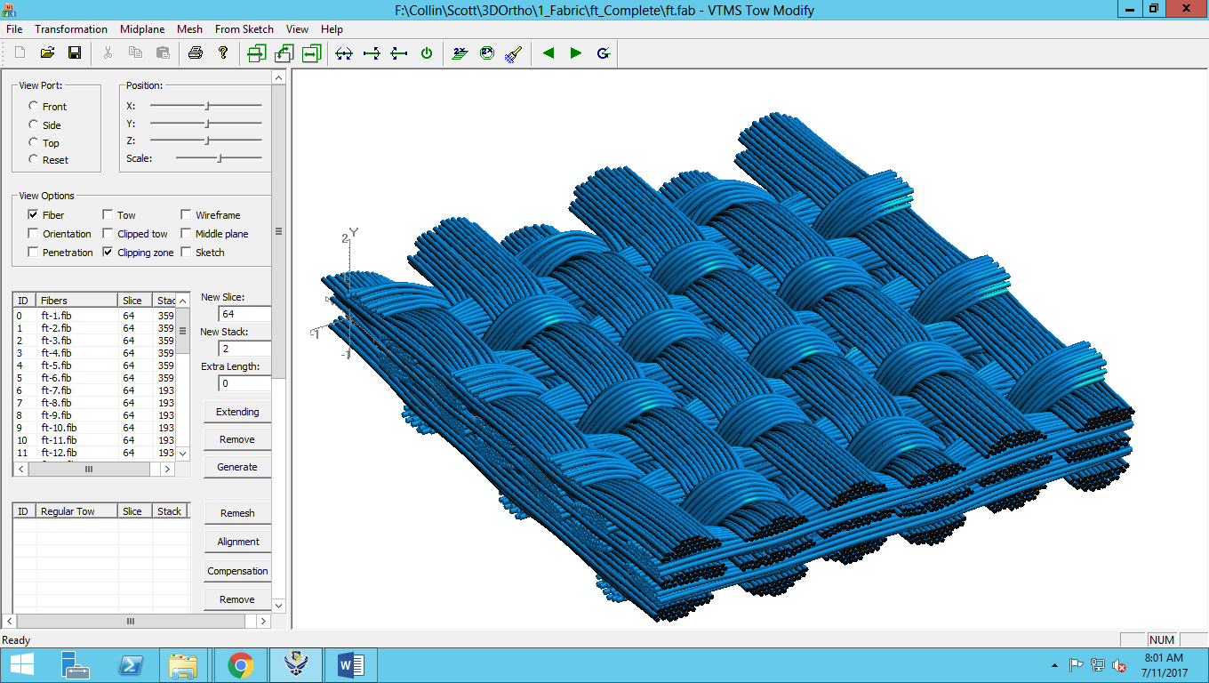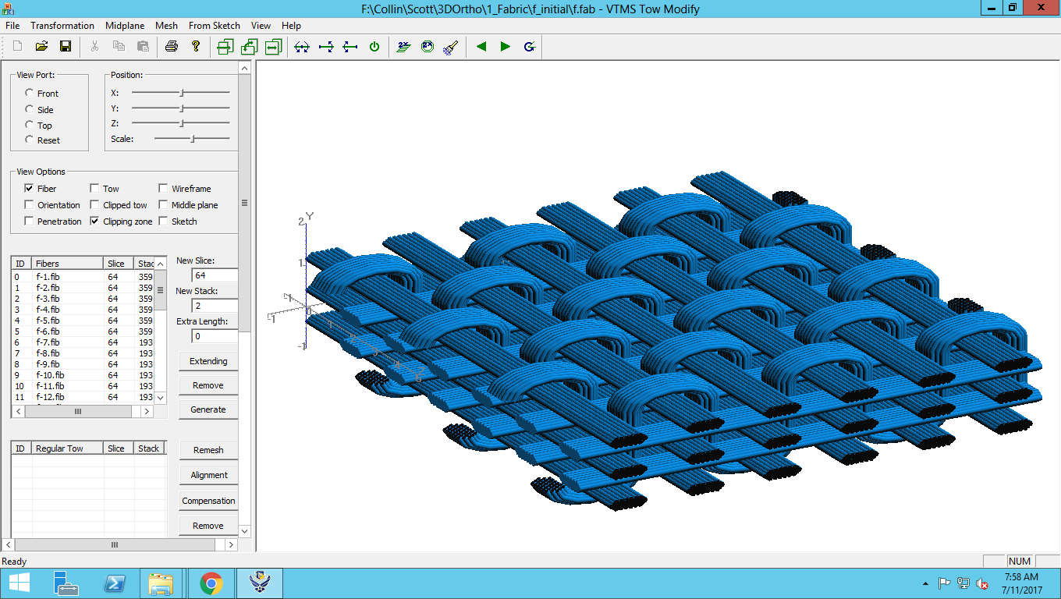

**Figure 2: Preliminary-to-Post Relaxation of Complex Fabric Geometry**

**Interpenetrations**

While at AFRL, Collin Blake explored the inner workings of VTMS while allowed access of the software code. Here, he gained even further understanding of how VTMS works and why the interpenetrations occur. He also discovered the method by which the software attempts to solve the interpenetrations on its own.

The surface fits (shown in Figure 1.c) result in regions of overlapping surfaces, which causes significant issues in meshing these models. These surfaces are defined by nodes that are connected in a fashion similar to a mesh. These surface nodes can be determined as penetrating another surface geometry by a method inside of VTMS. The focus of the last quarter has been to resolve penetrations between surface definitions of the textile geometry.

**Figure 3: Illustration of Penetration Phenomena**

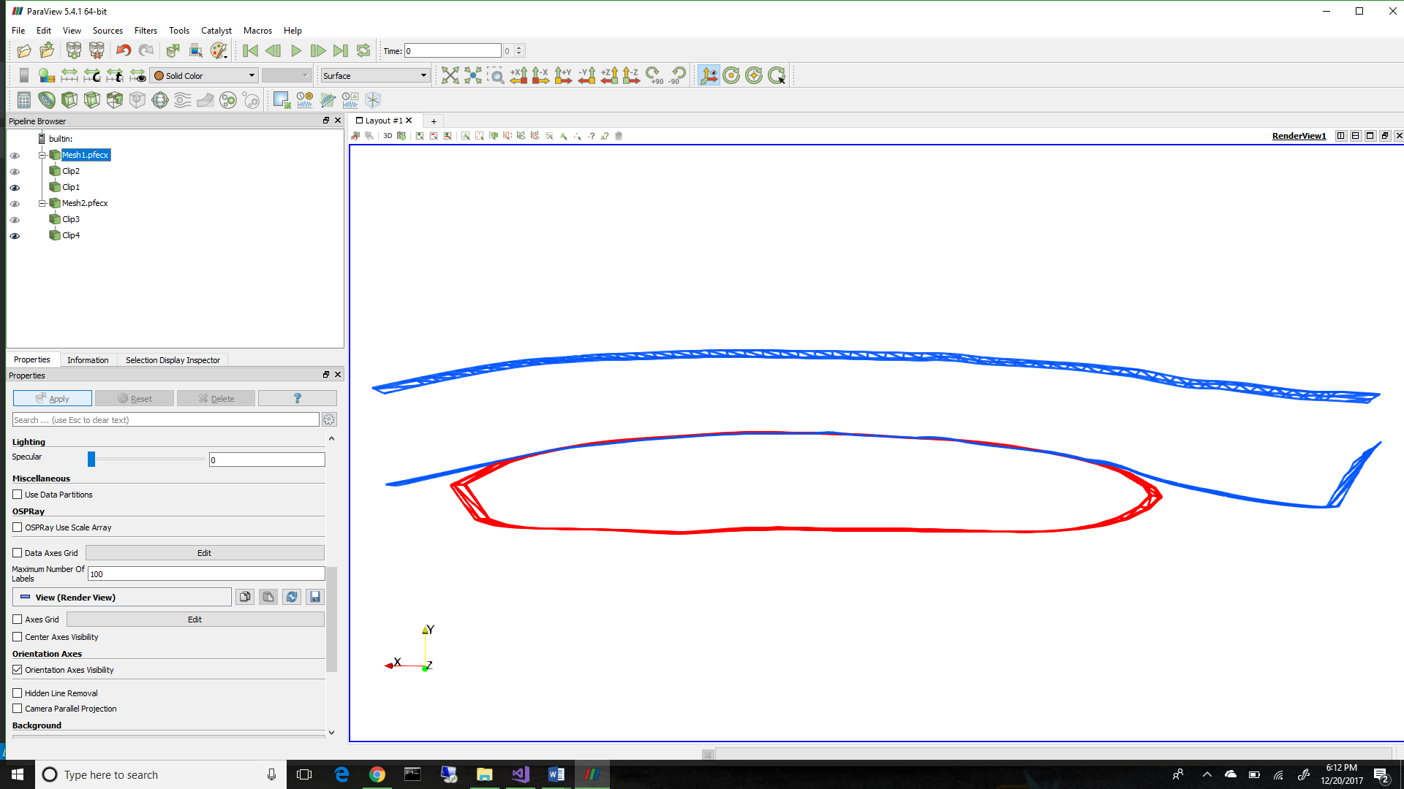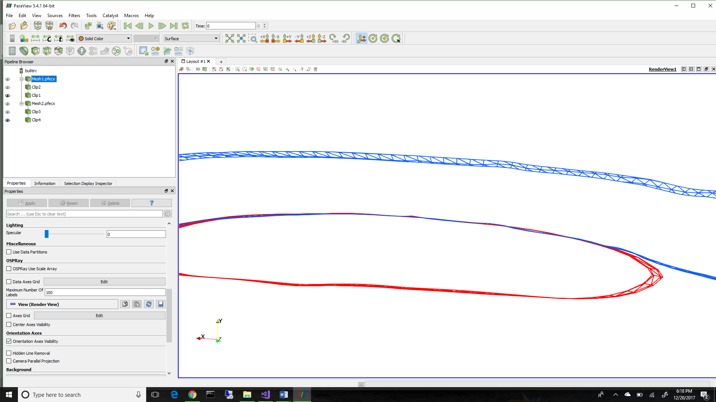

Figure 3 shows a representation of a series of penetrations between two geometries, one running in the plane of the page, the other running out of the page. Illustrated are multiple regions that need to be resolved.

**Identification of Interpenetrations**

Once the interpenetrations can be shown to exist, they must be able to be identified in their entirety to attempt to develop a solution. To implement a method to identify interpenetrations, the data that represents the surfaces must be analyzed. There are two types of representations to consider.

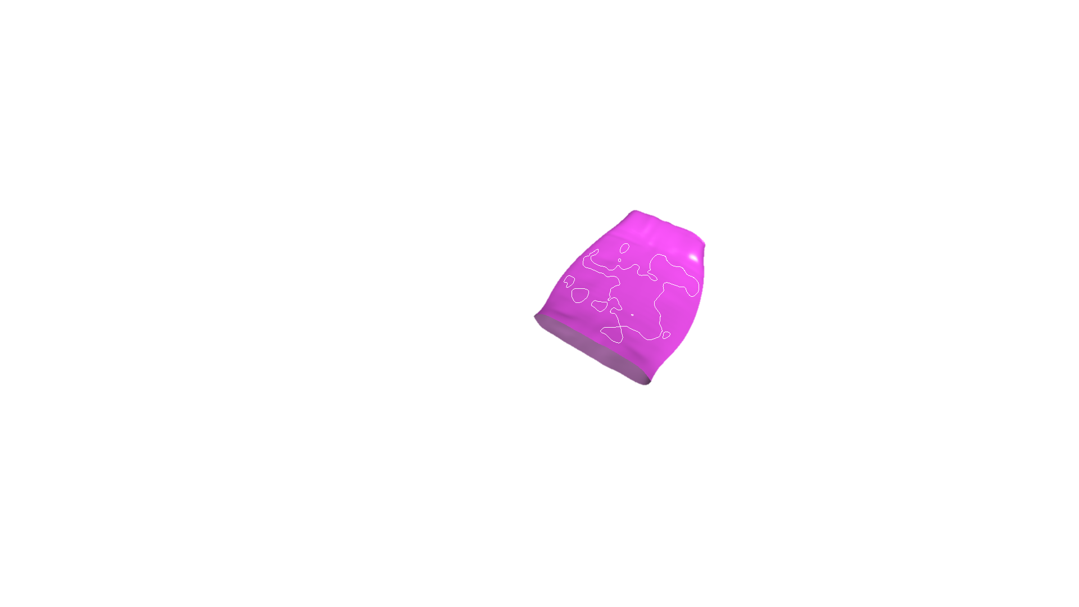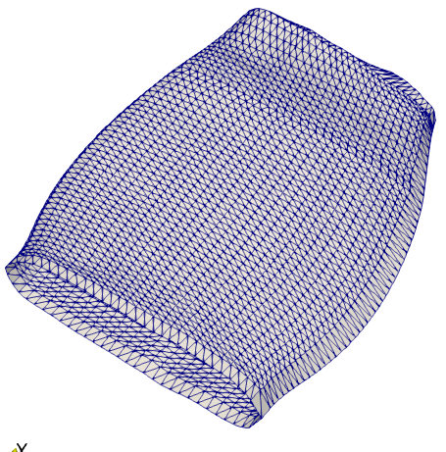

**a) Discrete Element Representation**

**b) NURBS Representation**

**Figure 4: Two Surface Representation Types for Tow Surfaces**

The first is a discrete form that is geometrical in nature. This representation simply described is made up of dots on the surface connected by lines very similar to a finite element mesh. This representation also can have surface elements that can be described by a series of lines as the edges of these elements. Figure 4.a shows such a description.

Another representation type is that of a mathematical representation. For this research, a Non-Uniform Rational B-Spline (NURBS) surface type was used. This representation is a collection of mathematical equations that can describe the surface in a continuous, analytical manner. This will be useful in determining an accurate description of the interpenetration regions. Figure 4.b shows the NURBS surface representation.

VTMS has its own method to identify interpenetrations. It uses the discrete description and conducts a ray intersection algorithm on a per surface node basis. VTMS creates a ray in a random direction and detects the element it intersects. The algorithm then establishes whether the node is in the inner side of the plane or not. It uses this method to identify and mark the nodes that have been identified as interpenetrating. This method is like one presented in [1], however does not pick up interpenetrations where element edges may intersect but nodes do not lie inside of a tow surface. This is the main drawback of VTMS’ identification algorithm.

Penetrating Node

Centroid

Element Outward Normal

**Figure 5: Surface Element with Penetrating Node**

The initial algorithm for identifying were developed during the time Collin Blake spent in his second summer at AFRL. This algorithm is very similar to VTMS’ original identification manner except that there is a search conducted first to find the closest opposing tow element to a given surface node. Then, a vector from the node to the average node location of the element is drawn. Then a dot product determines if the element normal and the node-centroid vectors lie in the same direction (refer to Figure 5). If so, then the node is contained by the tow. If not, the node is not interpenetrating. The nodes are labeled if they are determined to penetrate another tow surface. This method also does not test if edges are intersected. Here, I could add more about how the searching algorithm work, and how the surface elements are formed (this would discuss more about VTMS data formats).

The other method for identifying interpenetrations is to use the NURBS surface representation type. Because the surface can be described as a series of equations, the equations from two surfaces can be compared and set equal to determine exactly where they intersect. This method is difficult to implement, so a software library was found that was developed by the by the Geometry Group at SINTEF ICT, Department of Applied Mathematics. Once implemented, the interpenetrations can be defined as a region enclosed by boundary curves that lie on both surfaces. These curves are not guaranteed to be unique or closed, so an algorithm was developed to create unique closed curves from those returned from the library. Figures 6 shows how this data looks from VTMS to NURBS representation and Figure 7 shows the boundary curves directly from the SISL library. Here I could talk about how we go through exactly how the curves are defined. Also, I could add how exactly we check for overlapping curves and how we combine them. This method is mentioned briefly later, but not in greater detail.



**Figure 7: Surface with Penetrating Regions Outlined in White**

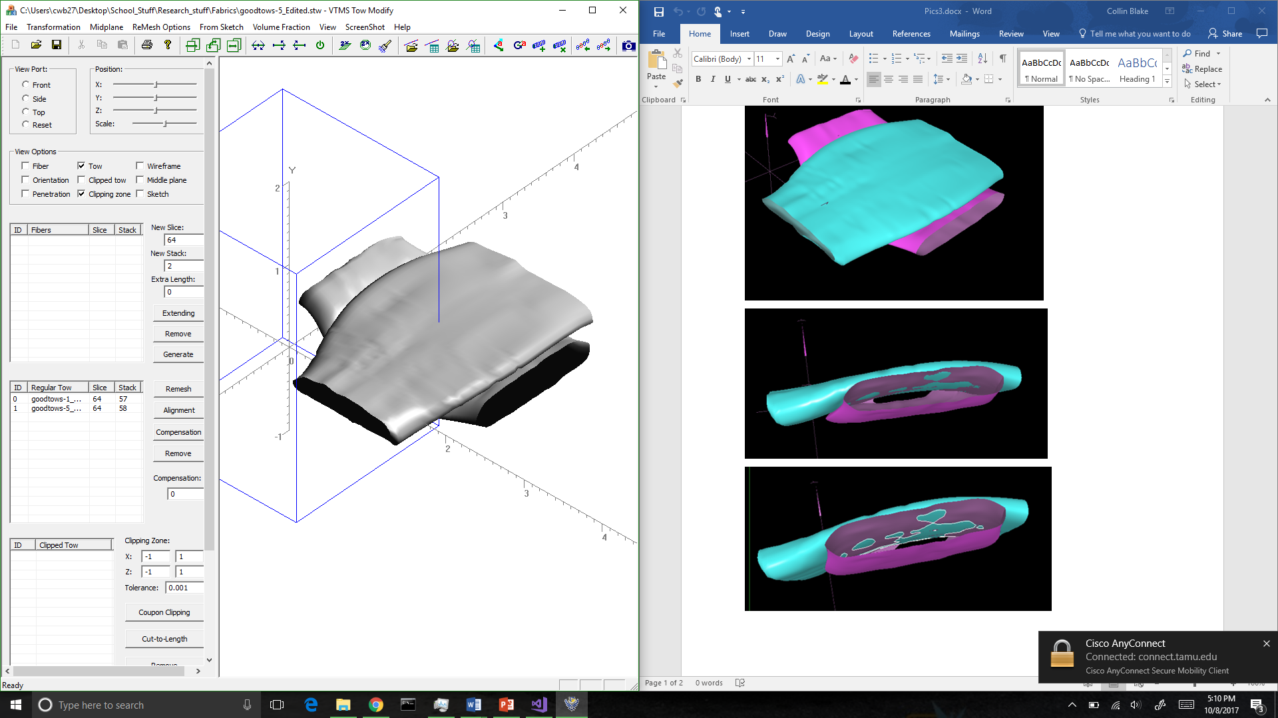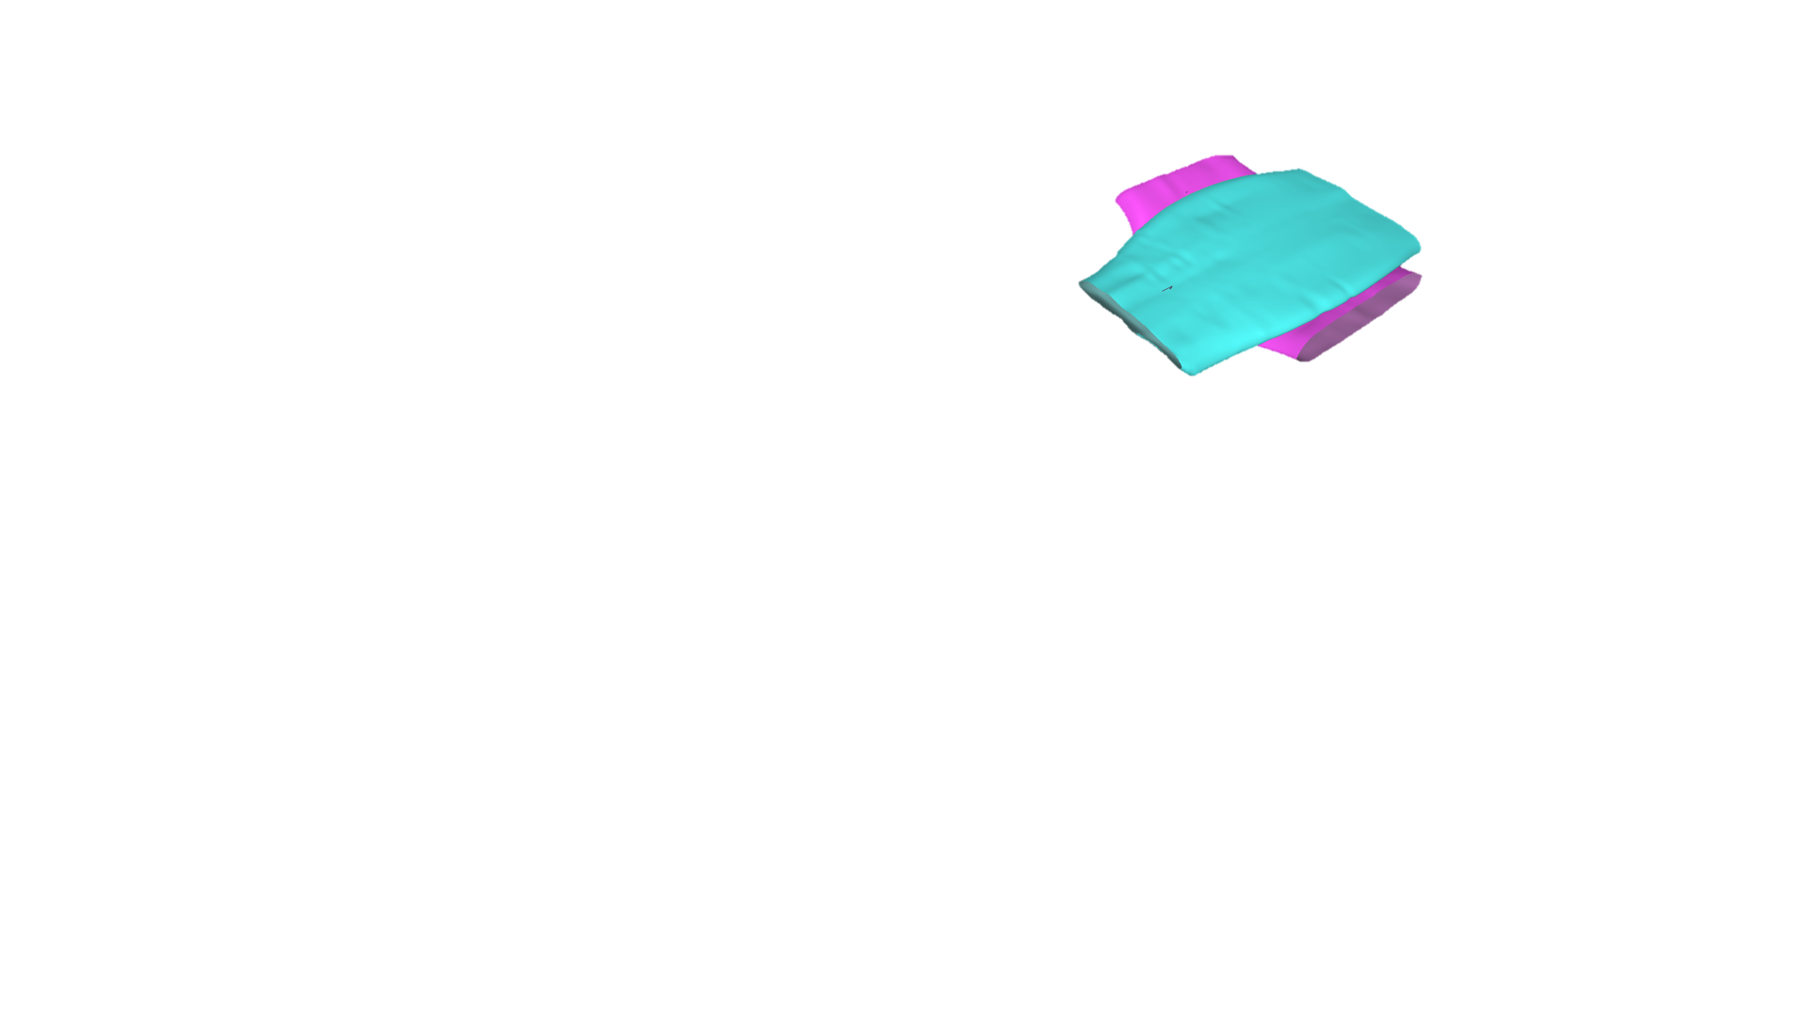

**Figure 6: VTMS Surface (Left) and a NURBS Representation (Left) of the Same Surfaces**

While the SISL library comes with its own viewer, it is not very powerful in its capabilities. A more powerful viewing software was needed to better understand the interpenetration problem. Paraview was chosen because this group has previous knowledge and plug-ins developed for this software. Multiple algorithms were developed for converting NURBS surface and boundary curve data so that it may be viewed in Paraview. It should be noted that while this data in its true form is continuous, it can only be shown discretely. Figure 8 shows a comparison of the original form versus the translated Paraview form of the data. To display the surface representation, there are two methods that can be used. The first is to simply use the point data supplied by VTMS and connect them by triangular elements to create a surface mesh. The other is to take the NURBS surface and evaluate the surface on an evenly spaced grid in the two parametric directions. This method will give us a more accurate method in displaying the NURBS surface over simply using the control points that describe the surface. This is also what the SISL library uses to evaluate the intersection between the two surfaces. The result of the two representations can be seen below in Figure 9. The blue surface is the VTMS data/control points and the red is the evaluated NURBS surface. You can see that they are very similar but not exact, which is expected. The difference between the two is minimal, however we have no metric as of yet to determine how much of a difference exists. A good metric to measure the difference in the two would be the volume occupied by each geometry.

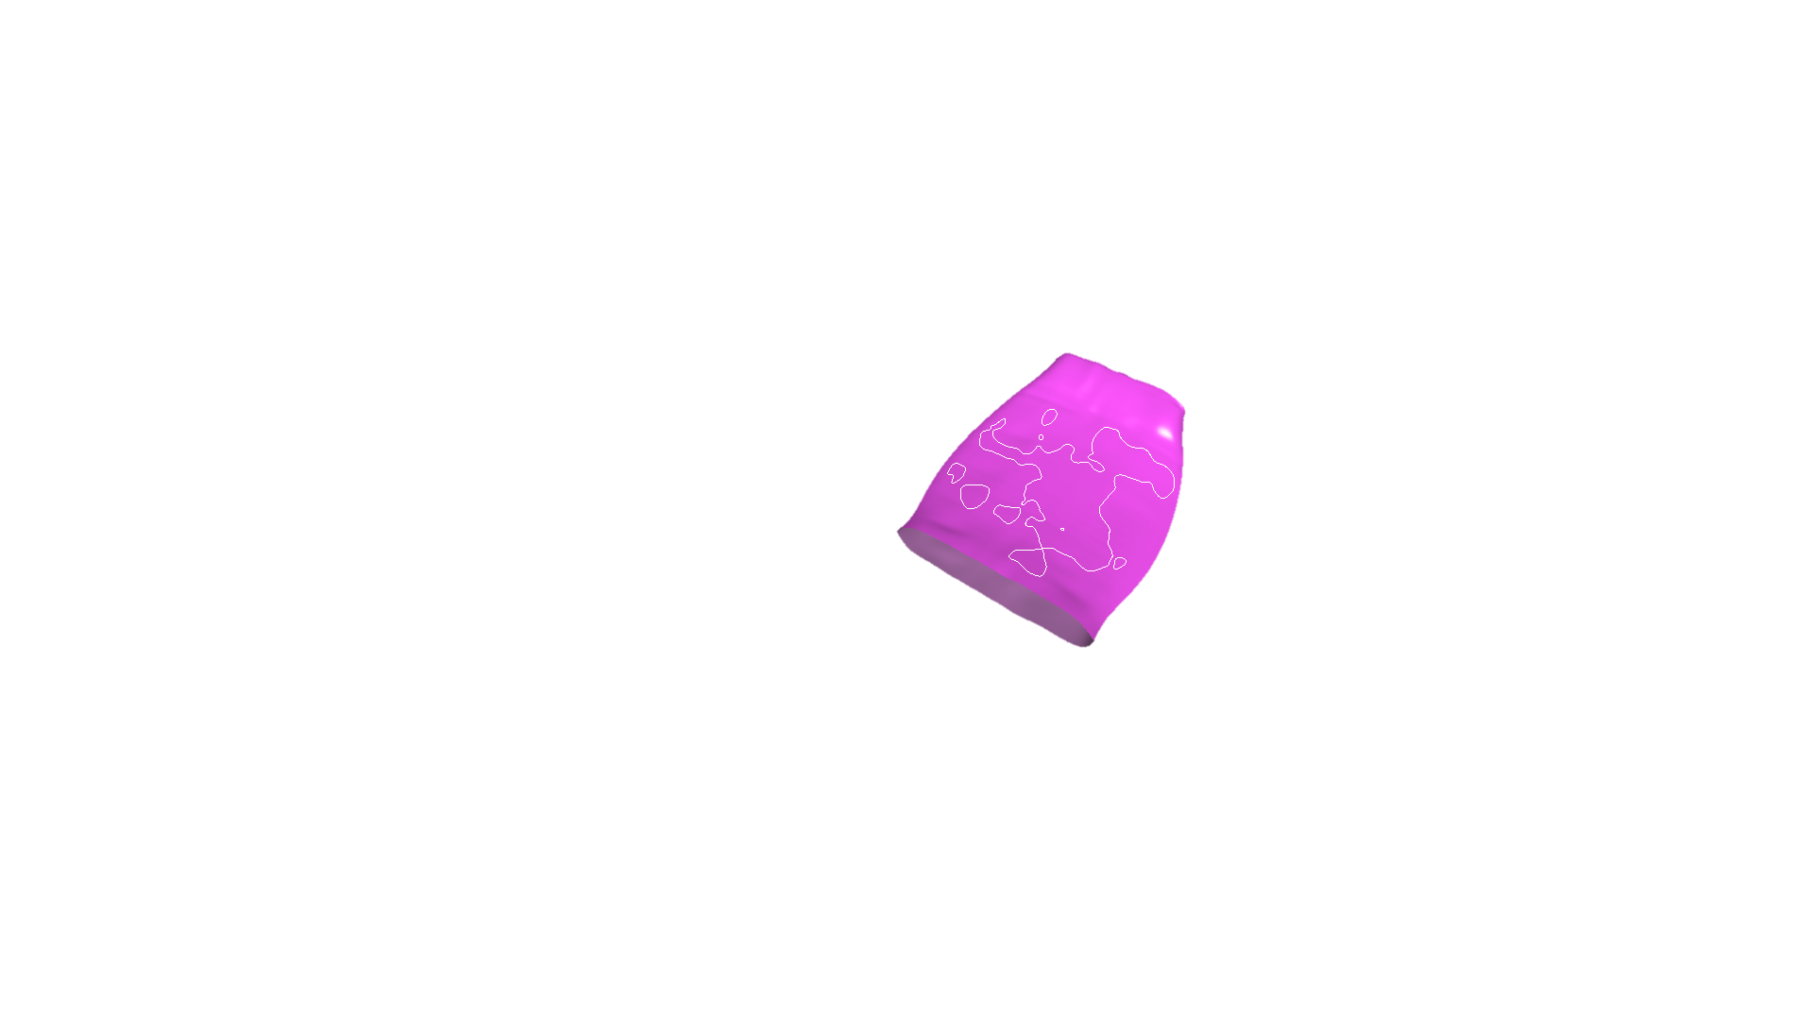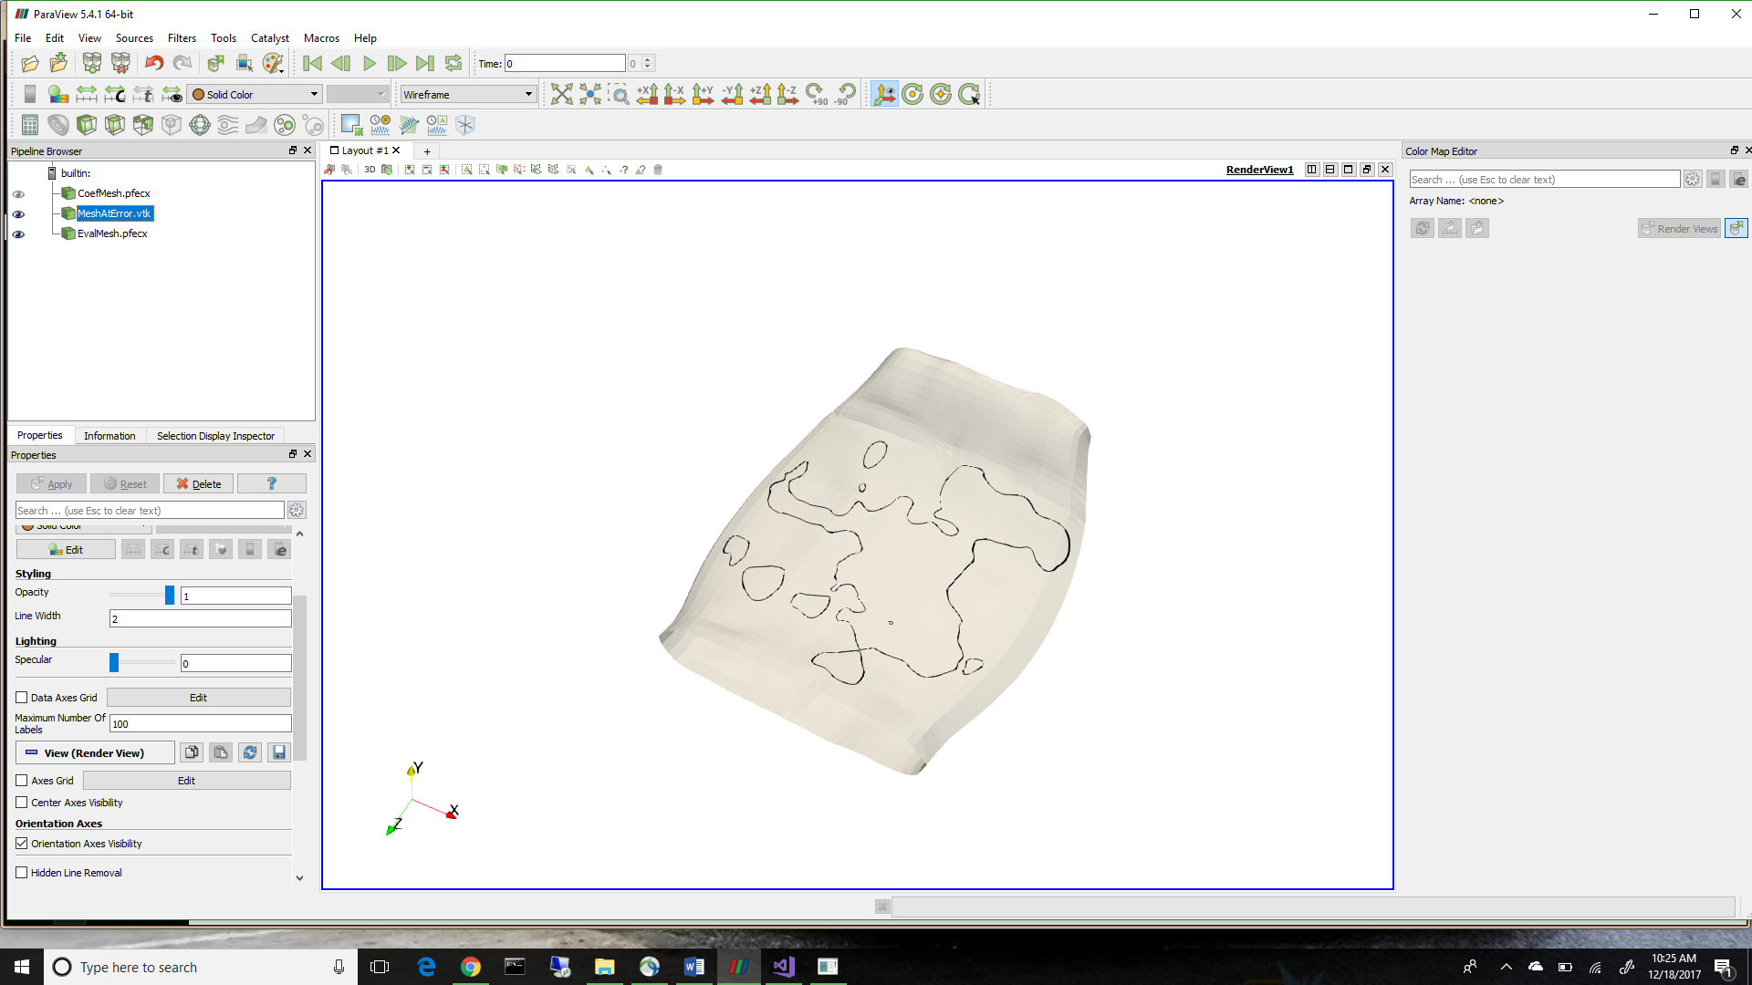

**Figure 8: ParaVeiw vs. SISL viewer of Translated Data**

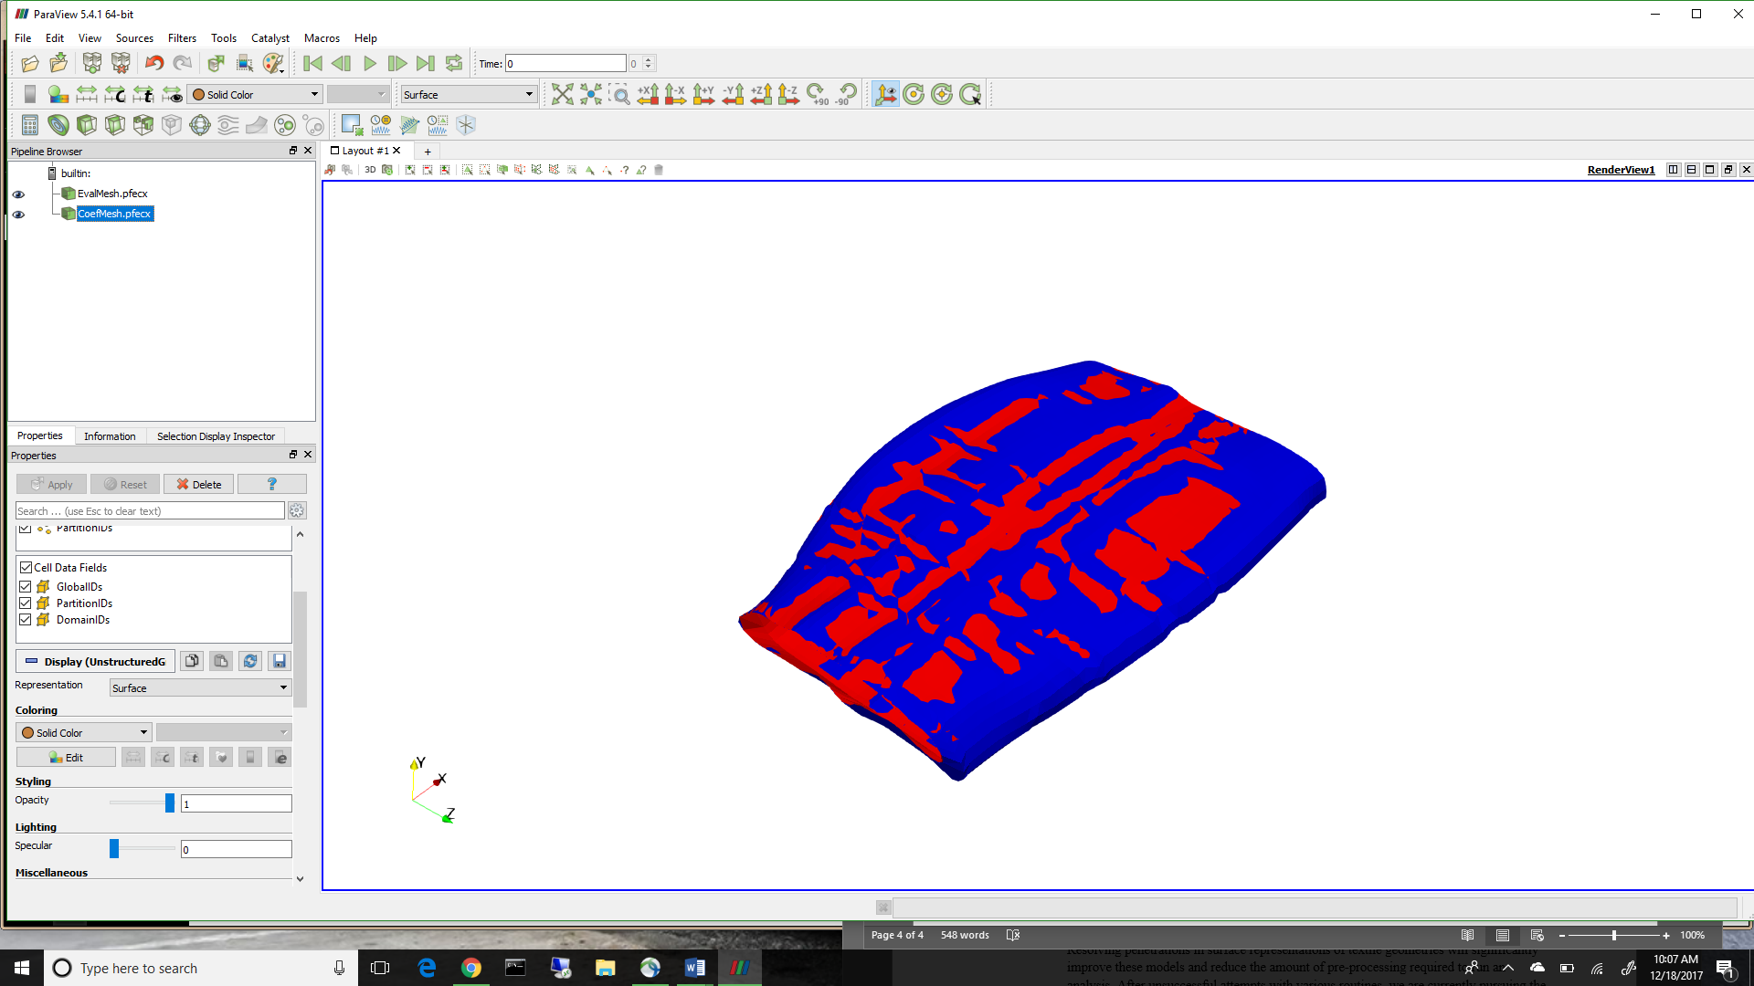

**Figure 9: A Comparison of NURBS surface and VTMS Data**

Now that the interpenetrations can be identified, a method to resolve them must be formulated.

**Resolution of Interpenetrations**

Each representation type requires its own resolution method. Therefore, each method is discussed with respect to its representation type.

The first attempt at a solution was with the discrete description of the data. The method is to define a plane that represents a contact surface between the geometries. This surface could then be used as a domain to resolve a penetrated region. This plane could also be used to define a compatible mesh between the two geometries for an analysis. It begins by collecting the known interpenetrating nodes from each tow intersection pair. The algorithm then calculates the average location of all of the points. The algorithm also finds the tow paths for the region of each tow that is interpenetrating. Using the tow paths, the direction of the plane can be determined and made to contain the average location previously mentioned. Then, every penetrating node is set to lie on this plane. Figure 10 shows the result of the algorithm. Unfortunately, this method could not be adapted for multiple regions of penetrations, as illustrated in Figure 3 above. This is due to the relatively large curvature of certain geometries along with the three-dimensional nature of the models. Here I could talk more about how the tow paths are calculated (using stack centroids) and also specifically how the nodes are being moved (i.e. the math and geometry)

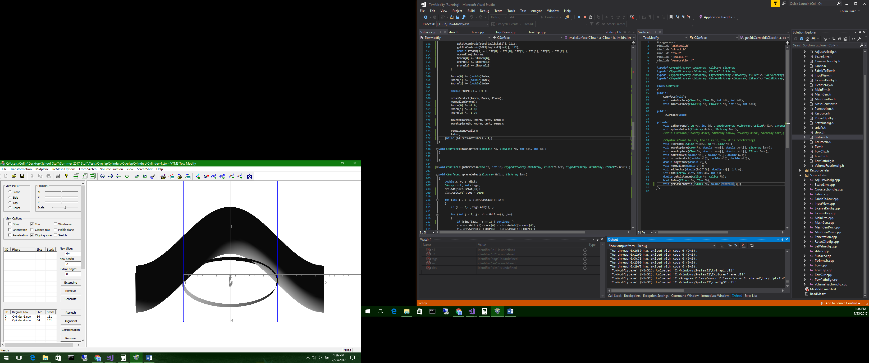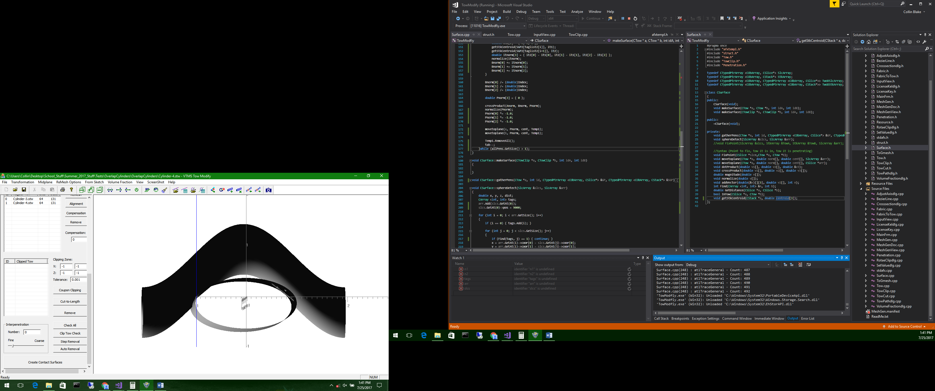

**a) Interpenetration before fix**

**a) Interpenetration after fix**

**Figure 10: Contact Surface Algorithm before and after**

The second method developed was a routine that paired penetrating nodes between the two surfaces by determining which nodes were in closest proximity. The routine then assigned both nodes to the halfway point between their original locations. This routine easily solved compatibility and solve the penetration regions. However, this solution was not robust for the case of single node penetration regions and resulted in some models having a significant change in surface geometry, as seen in Figure 11. Again I could discuss the searching algorithm and how we determine the locations between nodes.

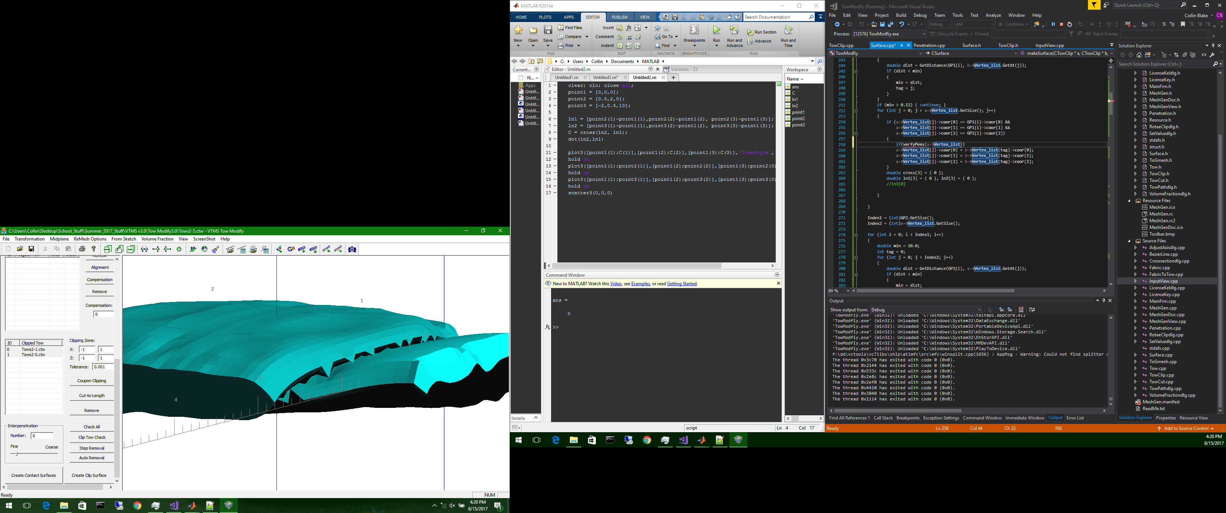

**Figure 11: Two Surfaces with Significant Boundary Changes Before (Left) and After (Right) Routine**

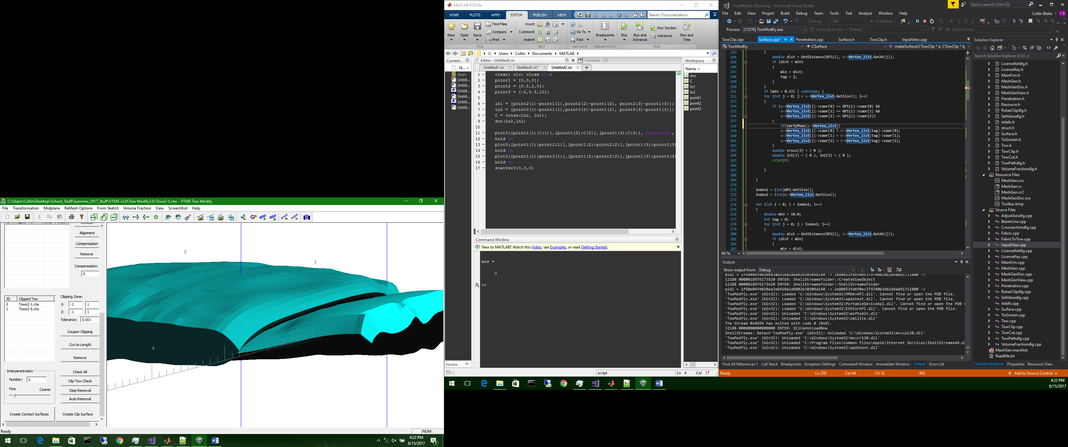

While the discrete representations (because they are directly from VTMS) reduce the error introduced when approximating the surface of the fiber bundles, they are difficult to use when solving interpenetration regions. Therefore, we decided to spend our time using the NURBS boundary curve regions to solve the interpenetrations. We can also use all of our previously developed mesh manipulation algorithms on these curves to do different operations we may find necessary. The regions returned from the library are described by multiple boundary curves that are not guaranteed to be unique or closed. The curves can remain open and overlap. Therefore, an algorithm was developed to test the curves against each other in order to consolidate any curves that overlap. The algorithm also removes curves that are duplicates. The impact of this step is not readily visualized, since the goal is to have the same regions identified, was accomplished.

A decision had to be made on what is needed to create a compatible mesh between the two tows where they overlap. The curve needs to have nodes where the curve itself intersects elements on the surface of each tow. Also, knowing which elements have been intersected by the interpenetration region boundary curves is useful in sub-meshing the intersected elements. The surface mesh and boundary curve interactions can be seen in Figure 12.

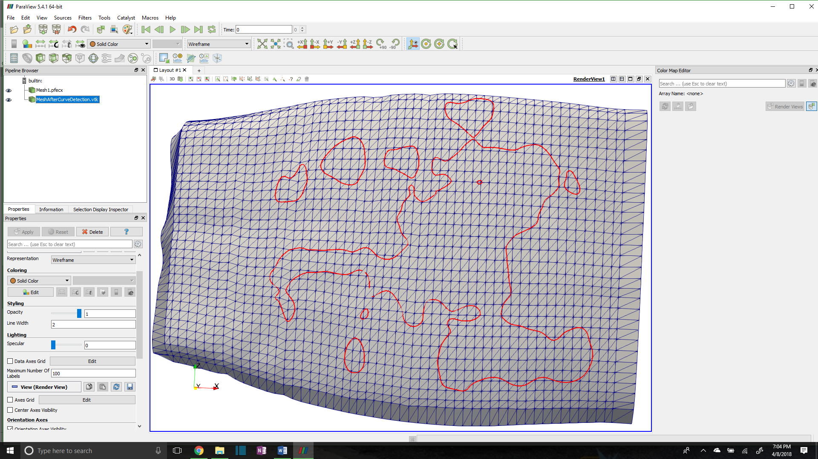

**Figure 12: Interpenetration boundary curve with tow surface mesh**

To identify which elements are intersected, and to refine the boundary curve where it intersects surface elements, the Separating Axis Theorem (SAT)**[1]** is implemented. The SAT starts by projecting the polygons onto axes. The projection can be thought of as the shadow of the polygon on an axis. The axes are created by taking the normal direction of an edge and creating an imaginary infinite line in the same direction. Figure 11 shows a projection of a triangle onto the red axis (RA) that is determined by the red edge (RE) and is parallel to the red edge normal (REN). The line segment along RA (labeled “Triangle Projection” is the projection of the triangle onto the axis RA in Figure 13. Three axes are identified, one corresponding to each side of the triangle.

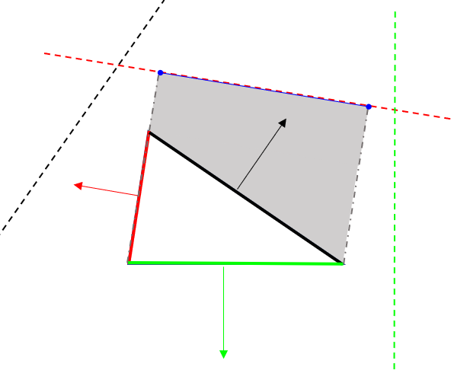

**Figure 13: Projection of a triangle on an axis**

**RA**

**REN**

**RE**

**Triangle Projection**

**[1] Method was found on website resource (**[**http://www.dyn4j.org/2010/01/sat/**](http://www.dyn4j.org/2010/01/sat/)**) as part of a game collision engine blog. Theory developed by Hermann Minkowski as Hyperplane Separation Theory**

Next, the projections are tested to see if they overlap. If there is an axis on which the projections do not overlap, then the polygons do not intersect. If the projections overlap on every axis, then the polygons do intersect. A reference picture is shown in Figure 14.

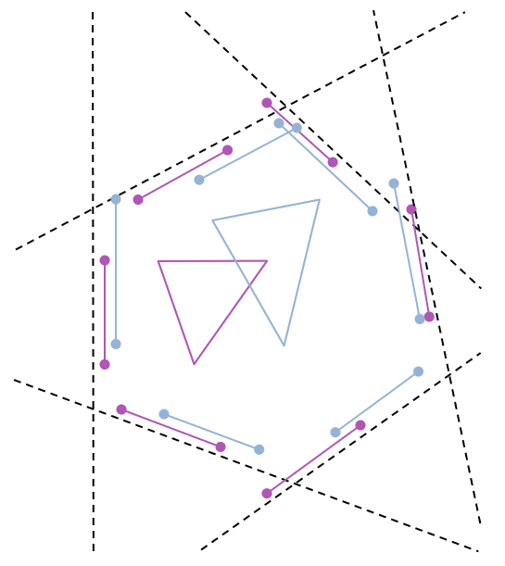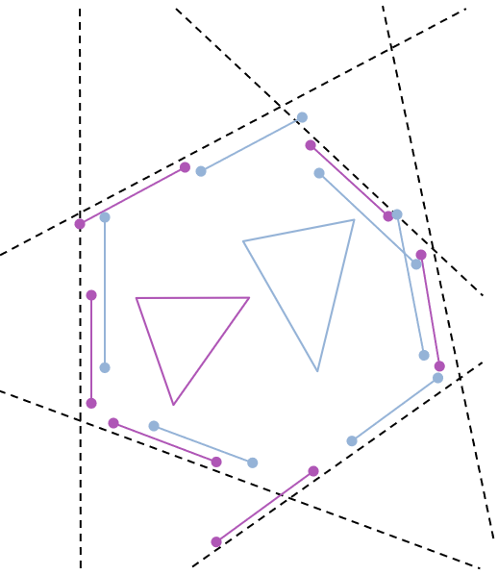

**a) SAT in which triangles overlap**

**b) SAT in which triangles do not overlap**

**Figure 12: Two cases for testing the Separating Axis Theorem**

In Figure 14.a), two triangles are shown to intersect. This can be verified by looking at each dotted line that represents a projection axis. Along each axis the bounds of the triangles are shown. There is no axis in which the bounds do not overlap. Figure 14.b) shows the case when the two shapes do not intersect. The axes (dotted lines) are the same in 14.a) and 14.b), since the orientations of the two triangles are the same, only the positioning is different. Circled are boundaries that do not overlap in 14.b) and therefore verify that the triangles do not intersect.

Once the intersected elements are identified, we determined which boundary curve segments intersect the edge of a tow surface element, create a node at which the segment and edge intersect, and add this node to the boundary curve. An example is shown in Figure 15 where the original nodes were the endpoints of the two line segments.

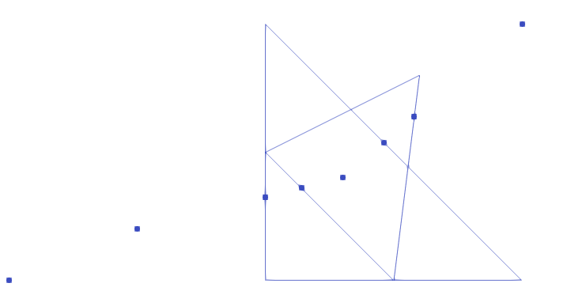

**Figure 15: Boundary Segments Intersecting an Element from each Tow**

We employ this algorithm for every intersection along both tows and their elements. This results in a boundary curve that is compatible with the two surface meshes where they intersect each other. This gives the information needed to enforce compatibility between the two surfaces.

The next step it to re-mesh the elements that have been intersected so that the shape of the curve can be captured within the surface mesh of both of the tows. This requires the intersected elements identified earlier. After we sub-mesh each individual element on both tows, we can add them back to the original mesh. The result is shown in Figure 16 and 17. Figure 16 shows only one boundary curve sub-meshed and appears as a thick blue line due to the refinement of the elements around the curve. The red lines show the remaining boundary curves that have yet to be sub-meshed in this figure.

Figure 17 shows some problem elements. The problem with some of these elements are their high aspect ratio. This can adversely affect an analysis in which they are used and can produce incorrect results.

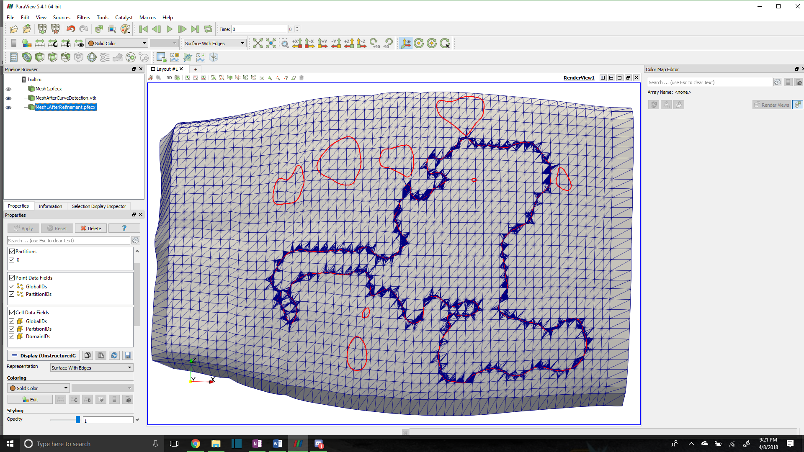

**Figure 16: Tow Surface Mesh with One Boundary Curve Meshed**

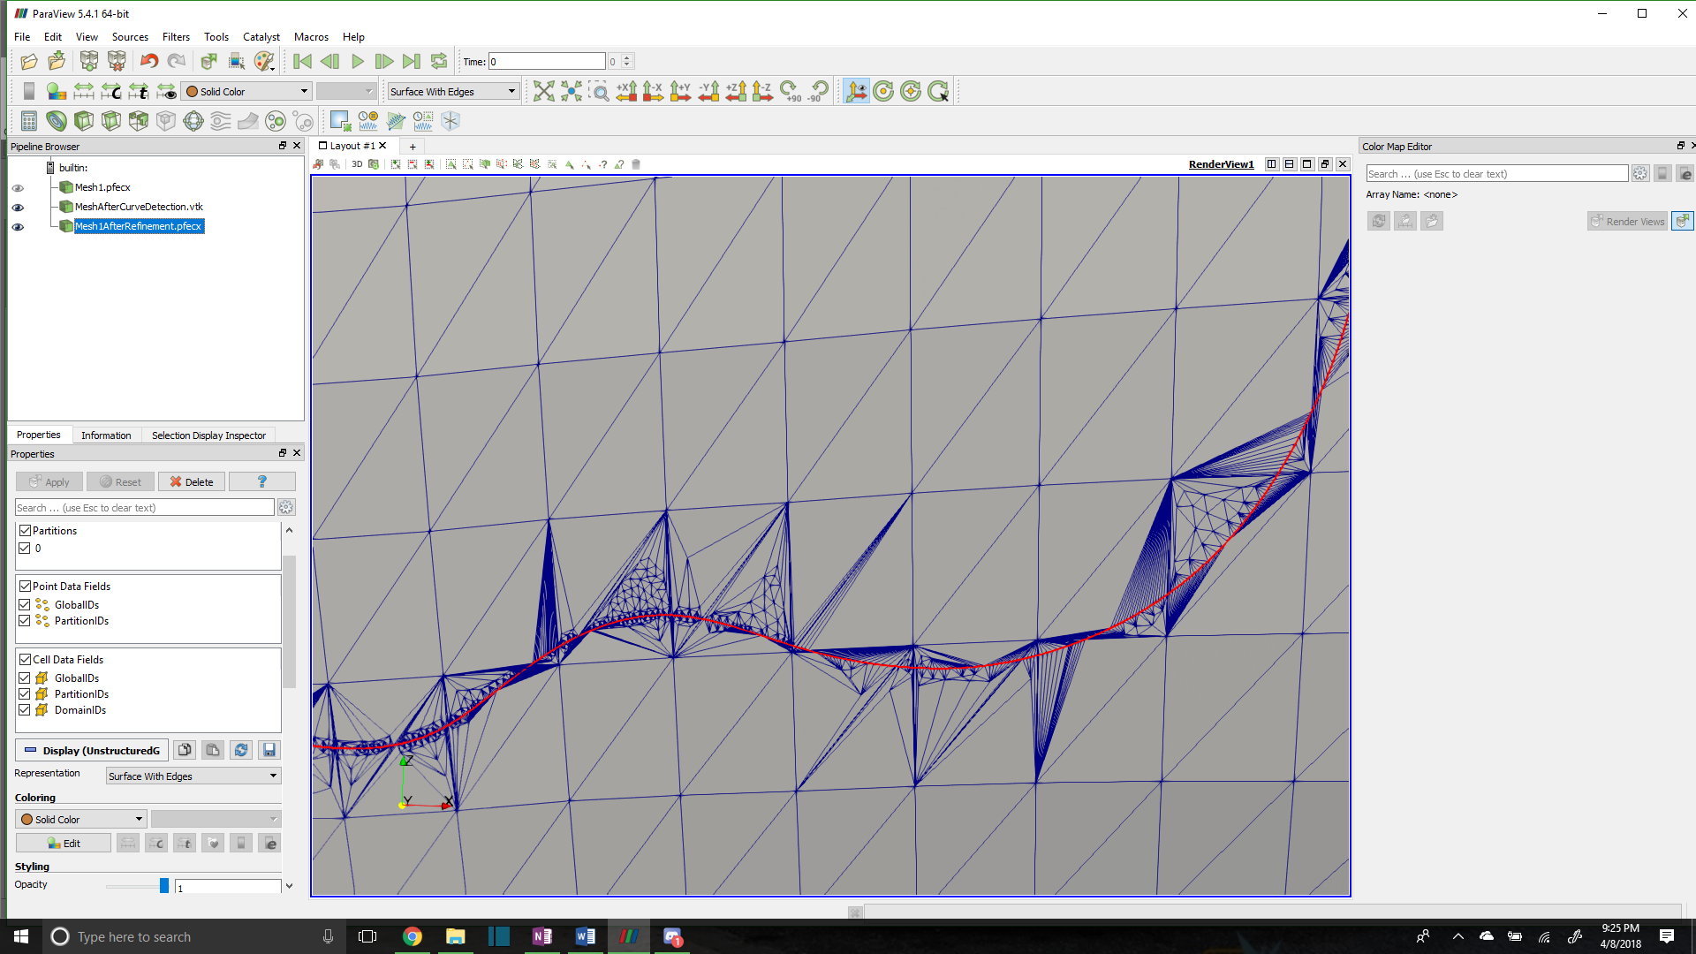

**Figure 17: Close Up View of Refinement**

The method to fix this is to record which nodes are added to the boundary curves due to intersections with surface elements and remove most of the boundary curve points that lie between any two element intersection nodes. This solution potentially loses some of the features of the boundary curve but will ensure that the tows no longer penetrate in the boundary curve regions. The result can be seen in Figures 18 and 19.

Figures 17 and 19 can be compared as they are the same section of boundary curve. The number of high aspect ratio elements is significantly reduced. However, there is still some evidence that these elements exist. The arise from when the boundary curve is too close to the corner of an element. Our solution is to implement an algorithm that when this situation is identified, the corner node will be moved to the boundary curve, essentially removing the interpenetration and enforcing compatibility in the same step.

**Figure 19: Up-close View of Reduced Refinement**

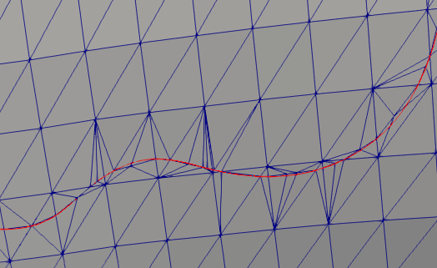

**Figure 18: Reduced Refinement Meshed Intersection Boundary Curve**

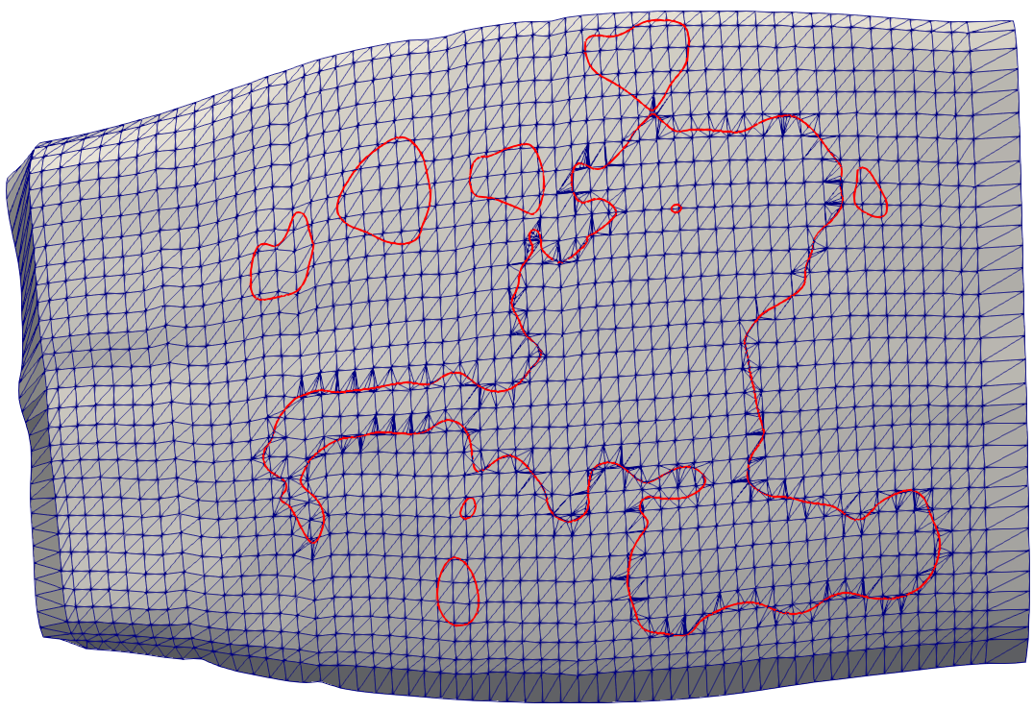

**We hope to add this fix before the due date of the report. Keith has also mentioned he has an algorithm written to collect the elements inside of the boundary curves so I will hopefully implement that as well before the deadline. Therefore the conclusion may change as well.**

* 1. **CONCLUSIONS/ANALYSIS TO DATE**

Interpenetrations regions between surface representations can be identified. The basis for identifying these regions is a NURBS library that can represent VTMS data as a NURBS surface and then identify the regions of interpenetrations by creating a boundary curve. Multiple methods for visualizing both the surfaces of the tow and the boundary curve of the interpenetration regions have also been developed. A low-refinement interpenetration boundary curve that is conducive to meshing can obtained. This curve can then be used to sub-mesh the tow surface mesh, enforcing compatibility between the two intersecting tows. While there are still some problem elements, a solution is being implemented to fix the scenario that causes these elements.